Projects

* Ambag Pathshaala
* Sewing Machine Training Course
* Oxygen Bank
* Zakat Distribution
* The Ramadan Project
* Disasters & Others

Ambag Pathshala:

Ambag Pathshala is an institution we have established to serve the quality education for the Childs who are underprivileged. The foundation has always been aiming to do something for the society no matter what it is, or how we have done it. Ensuring education for childs from all corners of the society is one of the keys we have focused on from the very beginning of our journey – said Fuad Khandakar. The School has named by the name of its locality called ‘AMBAG’ under SONARGAON, NARAYANGONJ. The school have provided education from play to grade two to the kids and its all free for the maximums in term of financial equivalence of them. Ther school have more than 50 students right now at all and more than 35 students are being financed by the foundation. Its including all the accessories , foods, medical support and many more. To run this school, we have spent 2,35000 BDT so far even having a very small finance and with many more challenges.

The executive panel took a decision to establish 5 more schools in five different locations and initially the budget requires 3,00,000 BDT

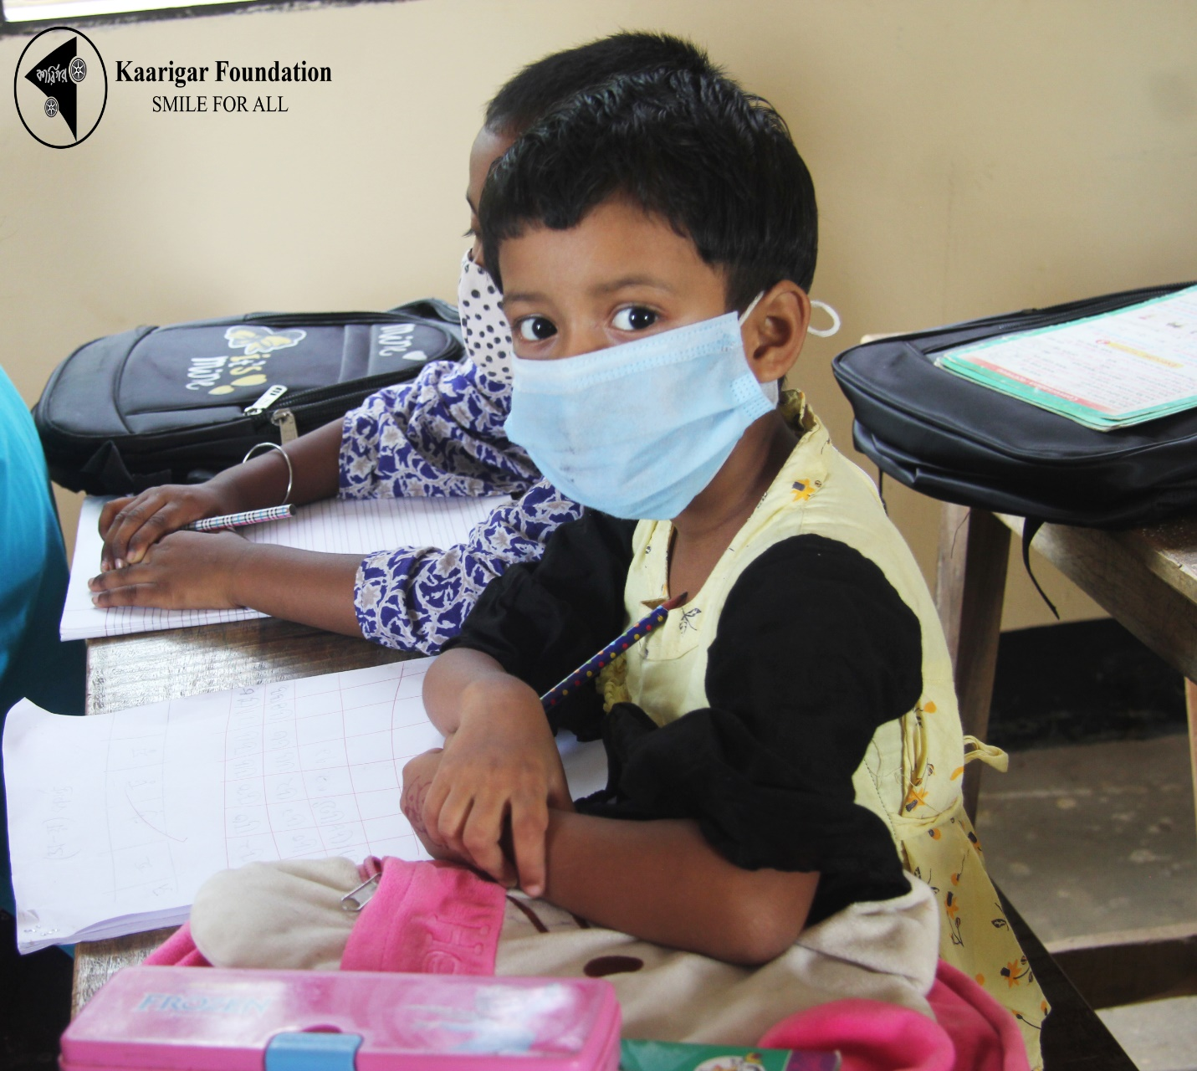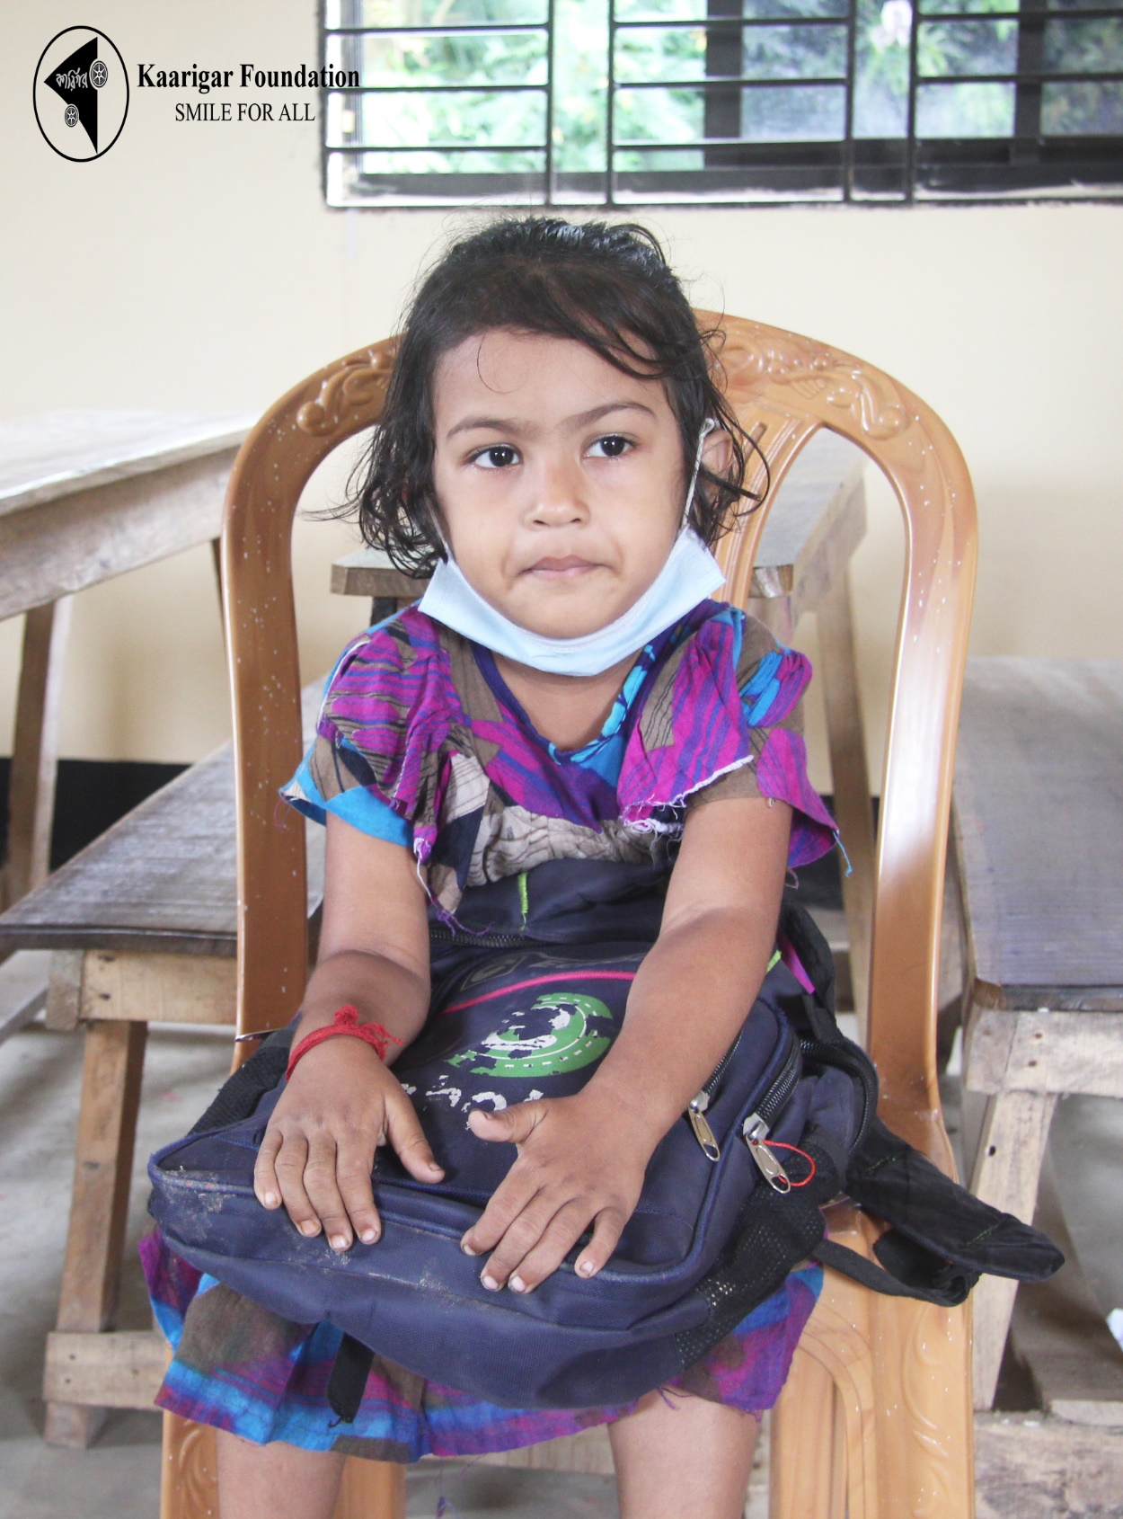

Sewing Machine Training Course:

Sewing machine training course is one of the

three big projects by the foundation

Followed by the 'BREATHSAVING PROJECT' and

'AMBAG PATHSHAALA’. The course is going on and Currently 30 ambitious but

Financially unable woman has enlisted themselves as they

wants to learn it. We're looking forward to start more batches

to help more peoples.

Kaarigar Foundation is always aiming to create employment or at least to show the way to be employed as unemployment is the biggest crisis of the nation right now.

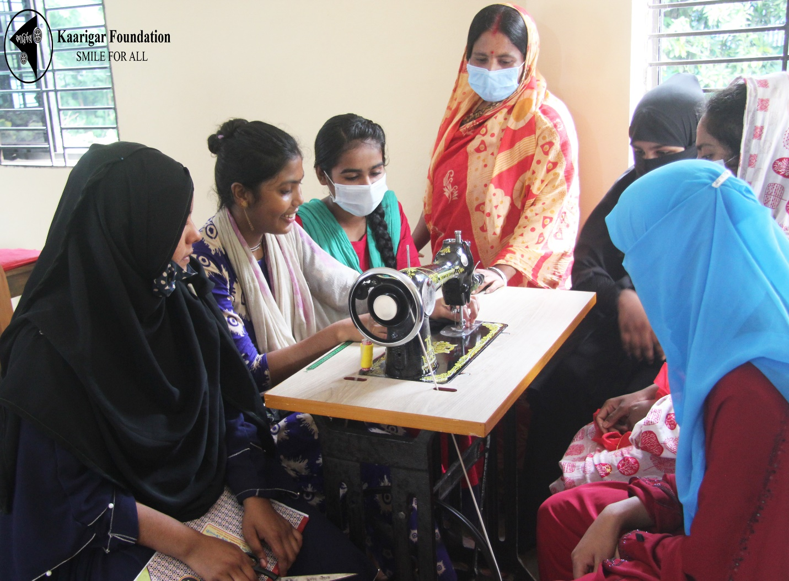

Oxygen Bank:

Oxygen Bank also called ‘the Breath Saving Project’ is considering as the most vital service the foundation have provided so far. At a very chaotic situation during the Covid pandemic, when even the hospitals were unable to manage enough Oxygens for the admitted patient the volunteers took the responsibility. They were on the move whenever it requires no matter whether it’s night or day. The peoples we titled frontliners at the pandemic definitely would love to have our volunteers as they provided Oxygens over 200 peoples hand to hand completely at free of cost.

The project costs almost 1,39,000 BDT so far and our service is still on going here and there inside Dhaka.

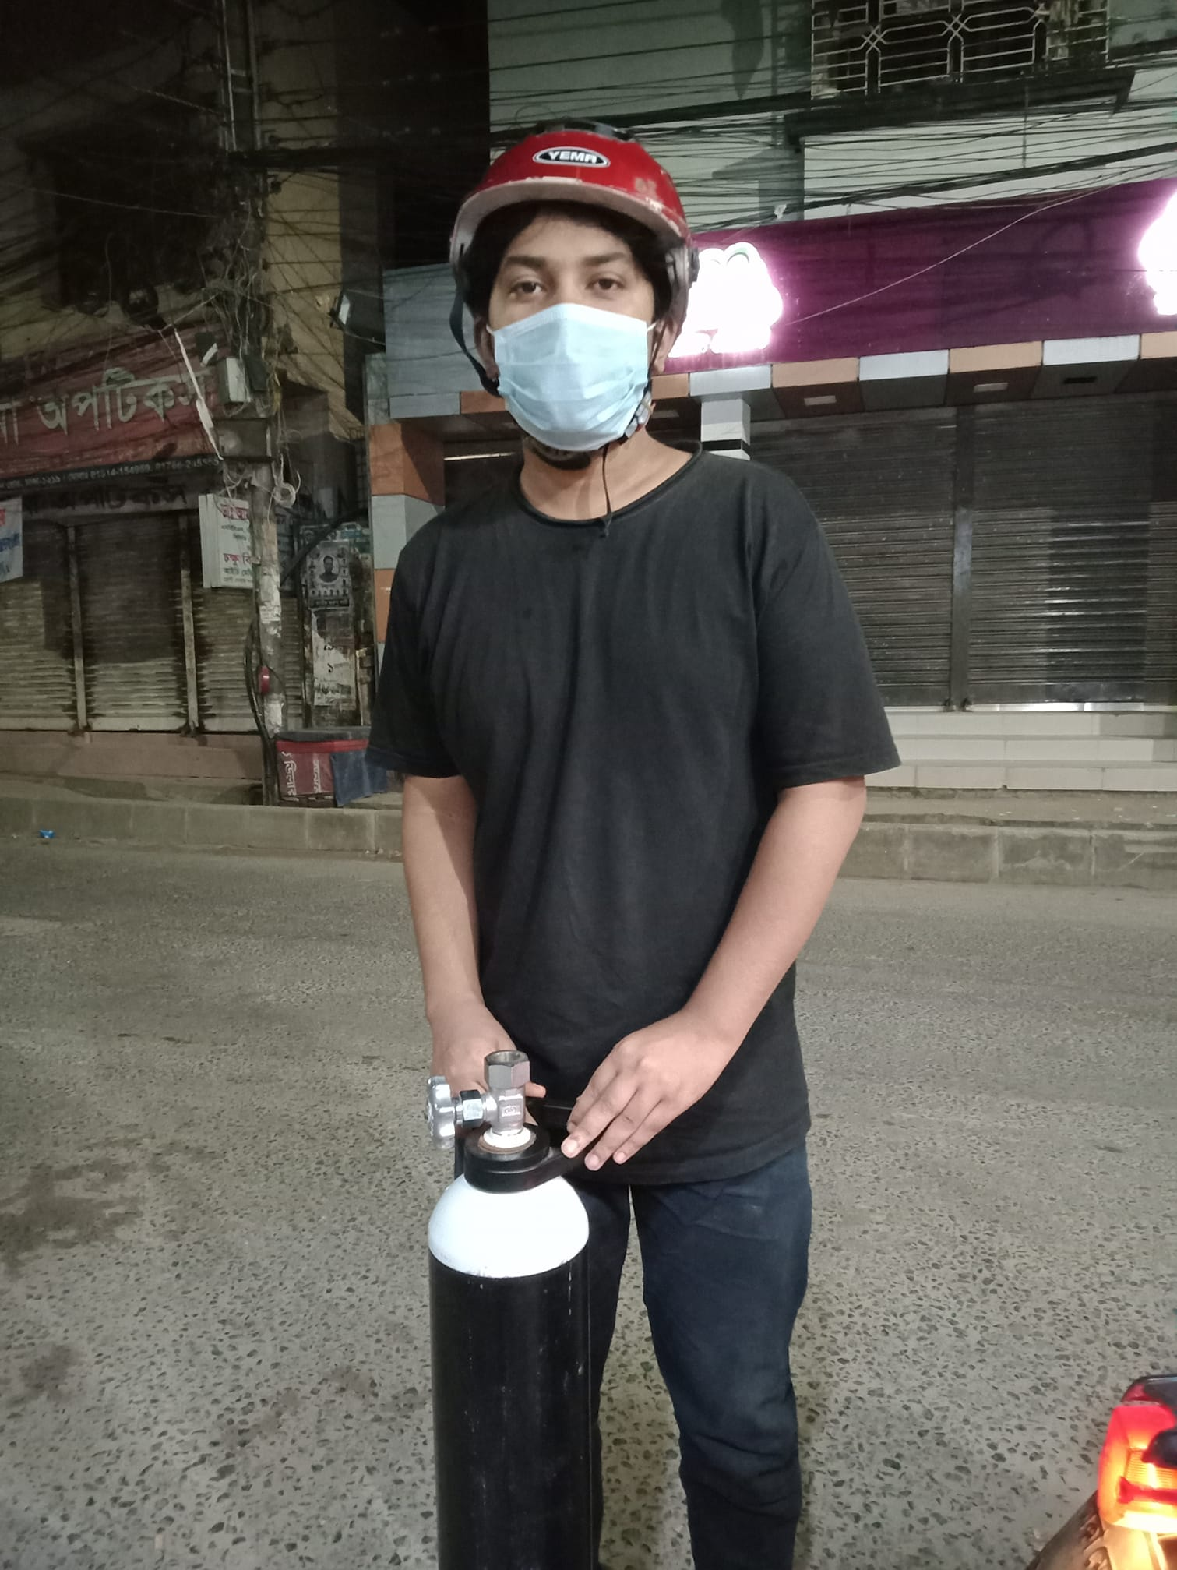

Zakat Distribution:

The Foundation has been distributing Zakat Collections amongst the listed people every year. As we all know, Zakat is a holy way to distributing money towards the needy. A list had created and has been updating over the years who can afford Zakat.

The Ramadan Project:

As the foundation always has focus on the needy, they never forget to do it in the holy month of Ramadan too.

Food, Water has been distributing amongst the people to break their fasting for the last couple of years. In the month of Sacrifice, the volunteers always had tried their best to serve the peoples.

At the holy festival called ‘Eid-ul-Fitre’ we have provided cloths, food items, toys to the kids and their family so that they can celebrate the festivals too. We have a believe that, the flag of no discrimination will fly one day by the hand of our next generation and who knows kids from our school maybe will take the lead for the revolution.

Disasters & Others:

We were always there when natural disaster occurs. From providing dry food to manage a space to sleep, the team have done it all!

